Functional Skills English

Entry Level 2 Work Booklet

Name:

Topic 1

Using Capital Letters

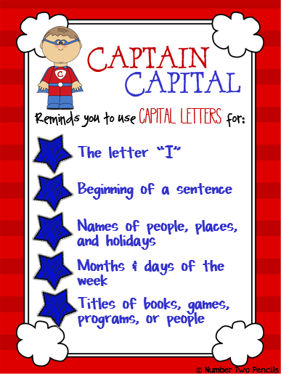
Recognise that proper nouns always have a capital letter. Proper nouns are names of people.
Write down five of your friend’s names in the box.

Proper nouns are names of places.
Write down five places you have visited.

Proper nouns are days of the week and months of the year.
Write down the month you were born and what day it is today.

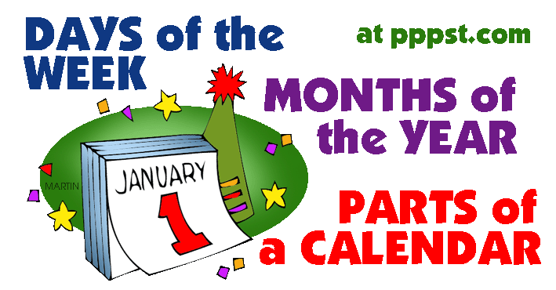

Capital letters are also used for people’s names, towns, street names and days of the week.

Look at this story and circle the letters that you think needs to be a capital letter.

on monday stephen and edward were taking their pet dogs, tilly and molly, for a walk. they walked down rooney avenue and as they entered the field a strange dog ran up to them. they were not sure what to do as it looked very thin and hungry. it just stood there looking sad, so they decided to take it to their mum. she said they would look after it and they put posters up in manchester, the city where they lived.

after a couple of days a woman called at their house. Her name was mrs walker. she was very happy that they had found her dog, whose name was ben. she gave stephen and edward twenty pounds each to say thank you.

A friend has written a letter. They have asked you for help. Can you find all the places they need to use a capital letter?
Circle each one -
3 Lindale Close
Addington
Ad16 3ty
Tuesday 2nd November, 2014
dear Ann,

thank you for dinner on Sunday. we hope you can come and see us when you visit Scotland in December. if you come after Christmas, i think Michelle will be here too. she would love to catch up with you before she goes back to Bolton. I hope I get a chance to speak to you on Saturday.

best wishes,

sam and lisa

Please rewrite these sentences with the correct capital letters.
are you going to manchester today?
_______________________________________
what time is it tom?
_______________________________________
i have been to france and spain.
_______________________________________
where is lisa, we should be at the disco?
_______________________________________
mrs walker talked to the boys.
_______________________________________
i like to go shopping in middlesbrough.
_______________________________________
my favourite food is pizza.
___________________________________
i like watching television.
_______________________________________
i am going on holiday to benidorm.
___________________________________
my favourite film is frozen.
_______________________________________

Put a tick in each box that you think should begin with a capital letter.
monday | sunday | spain | man
bolton | tree | apple | spring
tom | nice | autumn | middlesbrough
little | dog | city | manchester
may | rome | wednesday | peggy
town | pizza | garden | liverpool
january | gemma | summer | mother
france | father | december | country

Topic 2

Punctuation

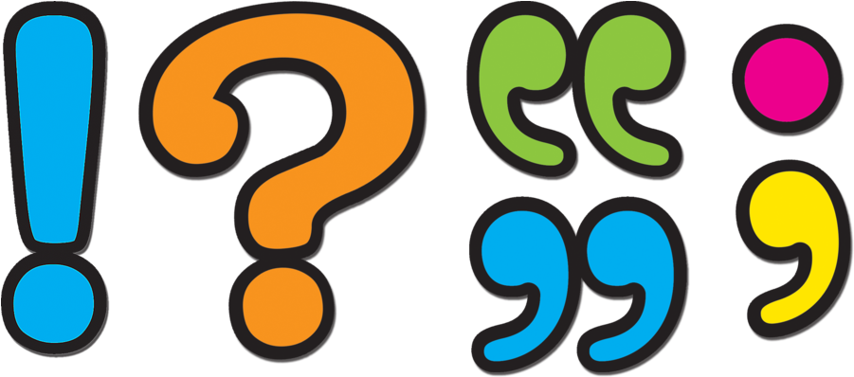

Punctuation – What does it mean?

Below are some meanings of punctuation to help you with your writing.
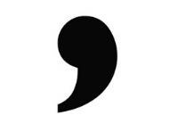
Comma
Commas are used when the reader needs to take a pause or when writing a list. E.g. I went to the shop for eggs, butter, milk and bread.
Full Stop

A full stop is used to show the end of a sentence. E.g. She went to the bank to get some money out.
Question Mark

This is used when asking a question. E.g. What time does this lesson finish?
Exclamation Mark

These are used to show commands, shock or surprise. E.g. Wow he is a really good singer!

Punctuation Match
Match the correct definition to the correct punctuation mark. The first one is done for you.

Capital Letter Used to separate a list of items. A natural pause in speech.

Full Stop . Used at the end of a command or exclamation to show feelings such as surprise, shock and excitement.

Exclamation Mark ! Used at the beginning of a sentence and also: names, places, the word I, days of the week and months.

Comma , Used to show the end of a sentence.

Question Mark ? Used to show a question.

Capital Letters and Full Stops
Write the following sentences out correctly, remembering capital letters and full stops.
- Put a capital letter at the beginning of a sentence.
- Put a capital letter for proper nouns (names/days/months/places)
- Put a full stop at the end of a sentence.

- yesterday, I fell over ben in the playground and hurt my knee ______________________________________________________________________________________________
- i think that i’m very smart because my test score was better than tim’s ______________________________________________________________________________________________

- jack and jill went up the hill to fetch a pail of water ______________________________________________________________________________________________
- christmas day is the day that christians celebrate the birth of jesus. ______________________________________________________________________________________________
- jennifer and michael are best friends ______________________________________________________________________________________________

Fill in the missing punctuation marks to finish these sentences.

- When is your birthday ___
- My sister hates football __ but I love it.
- What time does cricket finish __
- The man shouted really loudly__
- I went to the shop and bought some apples, bananas__ oranges and pears.
- Oh that really scared me__
- What time will you be in__
- I didn’t want to lose my socks__ gloves and hat.
- How are you today __
- Wow that is amazing __

Can you change these sentences to make them into questions?
1. You are going to the shop.
___________________________________
2. We are best friends.
___________________________________
3. They will go home soon.
___________________________________
4. You have got a big car.
___________________________________
5. We shall go bowling tomorrow.
___________________________________
6. We did have a great time last night.
___________________________________
7. You have bought a new pair of shoes.
___________________________________
8. I did go to school yesterday.
___________________________________
9. That is a very exciting book.
___________________________________
- It will be Gill's birthday tomorrow.

Now write 5 questions of your own.
_______________________________________________________________________________________________________________________________________________________________________________________________________________________________________________________________

Commas are missing from the sentences below. Can you add the missing punctuation to each sentence?
- Go past the white church turn left walk to the end of the street and you will see my house.
- Tom started writing his test two hours ago and he completed it by noon.
- Sara wanted to play with her friends yet the idea of completing her homework seemed more appropriate.
- I have no intention of celebrating my next birthday nor do I want you to have a party for me.
- My favourite foods are apples chocolate and chips.
- As a student I always had dreams of being a famous rock star.
- Doing a maths test is not difficult if you study for them.
- I go to Priory Woods School in Middlesbrough England.

Circle the exclamation marks in the sentences below.
Hooray I won the game - Hooray! I won the game!

1. I want to thank you for a great job!
2. When are we going home?
3. Thanks so much!
4. Please take out the rubbish.
5. Are you going to the game?
6. My favourite player got a goal!
7. Yay! We made it!
8. What a great job!
9. Please finish your homework.
10. Did you see the football game?

Now write 5 sentences of your own using exclamations marks.
_______________________________________________________________________________________________________________________________________________________________________________________________________________________________________________________________

Capital letter, question mark, full stop or exclamation mark?
ABC ? . !
Can you select the correct piece of punctuation for each of these sentences?
- Can i have a drink
Remember!
Full stop (.) – for a statement
Question mark (?) – if a question is asked
Exclamation mark (!) – for a command or strong feelings e.g. very excited/angry/surprised
Capital letters – beginning of a sentence and for names of people, places, months/days and for “I”

- Yippee
- It snowed last week
- My cat is called nigel
- stop that now
- How long until the school holidays
- How dare you say that
- What time is lunch
- did you have a nice weekend
- Tomorrow is tuesday
- look out
- I go to school in Chesterfield
- Why is it raining again
- my favourite colour is pink
- Go to Mrs Wise immediately

Spot the errors.
Use a coloured pen or pencil to correct the mistakes: once upon a time, there was a farmer called jack he lived with his wife and three children timmy, bob and rebecca they lived at the farm with all the animals they had a cat called tom, a cow called betty and dog called jim, a hen called clucky, a horse called ryan and many others animals near the farm there was a very naughty fox

his name was wolfie everyday the farmer had to lock the hens hut because wolfie loved eating the hens

he had tried many times to open the hut but he couldn’t the next day the wolfie watched the hens clucking and eating away he saw that it was getting bigger and bigger wolfe saw clucky and licked his lips

“tonight i will have open the lock and eat that hen for good,” laughed the wolfie and walked off
It had been a glorious day. Everything had gone as planned
the bride looked lovely and no one had kicked off sandra
breathed a sigh of relief. she had been so worried! She had
told everyone that careful planning would safe the day and
she had been right. If only people would listen to her more

Topic 3

Spelling

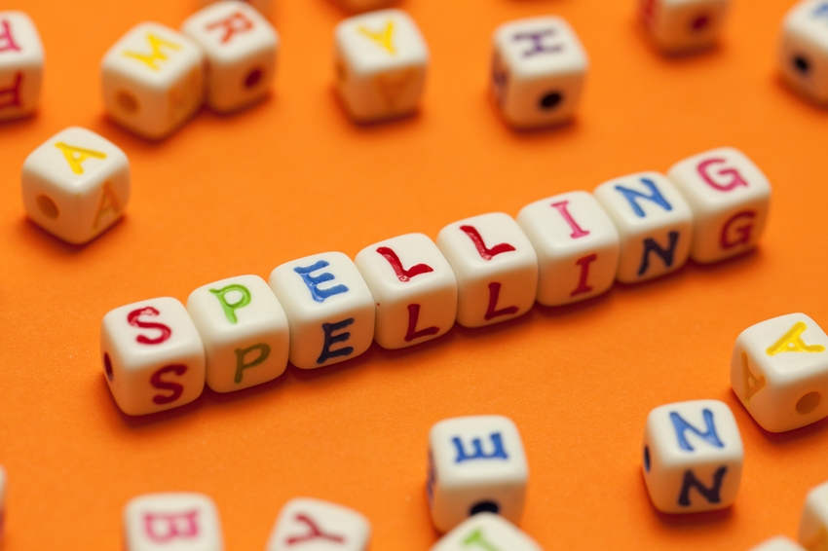

Write the words in the box in alphabetical order on the lines.
well wood water wind
1 ..................................................................................................
2 ..................................................................................................
3 ..................................................................................................
4 ..................................................................................................

Write the words in the box in alphabetical order on the lines.
dog dip den dab
1 ..................................................................................................
2 ..................................................................................................
3 ..................................................................................................
4 ..................................................................................................

Write the words in the box in alphabetical order on the lines.
food finish fan flick
1 ..................................................................................................
2 ..................................................................................................
3 ..................................................................................................
4 ..................................................................................................

Change the following words to plurals.
Singular | Plural
Hand
Cup
Horse
Chair
Car
Hour
Glass
Friend
Watch
Coin
Eye
Table
Can
Cake

Choose the correct word to complete each sentence.
Write the word in the gap.
The first one has been done for you.
Example: That’s my favourite subject.
subbject subbjekt subject subjeckt

(a) So many .............................................................................. live in London.
peeple peopel people peepal

(b) Do not .............................................................................. the glass.
break brayk breack braik

(c) We are going ....................................................................... tomorrow.
they’re thear their there

(d) Scotland is a beautiful .......................................................
kountry country countree kountrey

(e) I’m sorry, I don’t ................................................................ your name.
remmember remembir remember renember

amung among ammong amonng

(f) You are .............................................................................. friends here.

(g) My washing .............................................................................. is very old.
masheen merchine mashine machine

norty naughty naughtee norghty

(h) The .............................................................................. dog ran away.

(i) Please be .............................................................................. .
careful carefull cairful carefool

masheen merchine mashine machine

(j) I like to go to the .............................................................................. to study.
libery library libary libraree

Topic 4

Compound Sentences
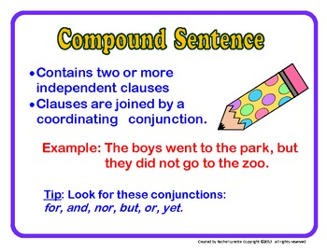

Compound sentences contain two or more pieces of information and are joined together by connectives (linking words).

Using connectives

Match the two halves of the sentences. Then use an appropriate connective from the box below to link them. Try to use each connective at least once.

1. ___ Portugal played well | - She got an A*
2. ___ It was raining | - He lost in the quarter-finals
3. ___ The teacher entered the room | - You’ll put on weight
4. ___ She studied hard | - It started getting dark
5. ___ We played football | - We went inside
6. ___ Joe was good at football | - He was violently sick
7. ___ I got in the bath | - They lost to Spain
8. ___ Federer’s a good player | - I don’t do it very often
9. ___ Billy ate a packet of biscuits | - He was a great swimmer
10. ___ You don’t do any sport | - The students fell quiet
11. ___ I enjoy cycling | - They didn’t play their best
12. ___ England has some great players | - The phone rang
although as soon as because but if

in addition since so until when and

Simple and Compound Sentences
Simple sentences - Simple sentences have only one clause. This means that they have one subject and a verb.
Example: The lion growled.
Compound Sentences - Compound sentences are two or more simple sentences joined with a connective.
Example: The lion growled but the mouse wasn’t scared.

TASK
Read the sentences in the table below and tick the boxes to show whether they are compound or simple sentences.

Compound Sentences
Write some compound sentences using the words on your connective word mat. Don’t forget to put a full stop at the end of your sentence!
___________________________________________________________________________________________________________________________________________________________________________________________________________________________________________________________________________________________________________________________
_______________________________________________________________________________________________________________________________________________________________________________
Topic 5

Adjectives

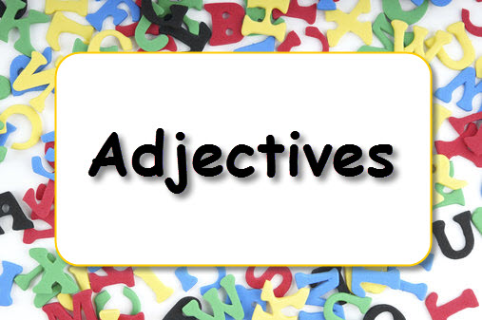

Be creative - what could you replace ‘nice’ with?
He was a very nice man. ________________________________
Last night’s meal was nice. ______________________________
She is always nice. ____________________________________
The children’s behaviour was very nice. ______________________
__________________________________________________

Be creative - what could you replace ‘good’ with?
He is good at swimming. _________________________________
I had a good time last night. _____________________________
The play was good. _____________________________________
I got good feedback for my work. _________________________
___________________________________________________

Be creative – what could you replace ‘fun’ with?
The party was fun. _____________________________________
I am having fun. _______________________________________
Ice skating is fun. _____________________________________
School is fun. ________________________________________

Make a list of positive and negative adjectives
Positive | Negative
Topic 5

Writing

Here is an example of a library card.

Address

Phone Phone

Date of Birth Mobile
Email

jbloggs@supermail.com
07896345213
01204 768798
12 Bright Street
Bolton
Lancs
BL8 7RT

12/06/1984
Name: Joe Bloggs Bolton Library

Using the following details fill in the library cards like the one above on the next page.
Leanne Smith lives at 34 North Road, Bolton, BL8 7GD. Her email address is l.smith@googlemail.com. Her phone number is 01203 678987 and her mobile number is 07865234765. She was born on 23rd October 1976.
Marcus Jones lives at 276 Whittle Street, Bolton, BL8 3HG. His email address is Marcus.jones@firmail.co.uk. His phone number is 01204567543 and his mobile number is 07564231876. He was born on 5th July 2000.
Name: Bolton Library

Address

Phone

Date of Birth Mobile
Email

You want to join a cooking club.

Address

Phone

Mobile

Date of Birth Email

Name: Bolton Library

Fill in the form.
Cooking club

Full name ..............................................................................................................................House/flat number .............................................................................................................................. Street.................................................................................................................Town.................................................................................................................... Postcode ............................................................................................................
Email....................................................................................................................
Please write four sentences to tell us:
- what you like to eat
- what you want to learn to cook
- who you want to cook for
- what day you can come.
..............................................................................................................................
..................................................................................................................................................................................................................................................................................................................................................................................................................................................................................................................................................................................................................................................................................................................................................................................................................................................................................................................................................................................................................................................................................................................................................................................................................................................................................................................................................................................................................................................................................................................................................................................................................................................................................................................................................................................................................................................................................................................................................................

Write an email to a friend about a TV programme you have seen recently.
Write four sentences to tell your friend:
- what programme you saw
- what you liked about it
- what you didn’t like about it
- why you think your friend will like it.
You must include at least two compound sentences using joining words, for example: and, as, but, or.

You must use at least one adjective.

You must use at least one linking word, for example: also, then, because, so.

Write your email on the next page.

Topic 6

Reading

- Where is City Shopping Centre?
..................................................................................................................................................................................................................................................................

The text tells you:
You may use a dictionary to answer this question.
‘You can hire wheelchairs’
What does hire mean?
Name two things you can buy in the shops.
1 .................................................................................................................................
2 .................................................................................................................................

Which floor is the cinema on?
..................................................................................................................................................................................................................................................................

Which one of these is true?

The bullet points tell you what to do:

Name one thing you should do the night before.
..................................................................................................................................................................................................................................................................

List three things that you must not do on your first day.
1 ..................................................................................................................................................................................................................................................................
2 ..................................................................................................................................................................................................................................................................
3 ..................................................................................................................................................................................................................................................................

Name one thing you should do with people at work.
..................................................................................................................................................................................................................................................................

Read the sentence below.
It’s important to ask questians if you’re unsure.

The word questians is spelled wrongly.
Use your dictionary to find the correct spelling. It is:

